Track Multiple Domains in a single Google Analytics Account

For every analytics statistics, data accuracy is the most important factor to know the website performance. If you are a business man who have a multiple domains and subdomains which you want to track the data in a single Google analytics account. To resolve this kind of problem, here is the solution for you.

Let us assume that one person has three domains called www.a.com, www.b.com and www.c.com. You want to track all these sites detail in a single Google analytics account. The following steps will explain you the process of how to do that.

Step 1: Create three different Google Analytics account for each domain. For example we will take the following account viz UA-AAAAAAA-1, UA-BBBBBBB-1 and UA-CCCCCCC-1

Step 2: Now we need to create for the overall account which can show all the three domain details [ UA-ddddddd-1: this is the example account id we are going to use in our overall tracking account ]

<script type="text/javascript">
var gaJsHost = (("https:" == document.location.protocol) ? "https://ssl." : "http://www.");
document.write(unescape("%3Cscript src='" + gaJsHost + "google-analytics.com/ga.js' type='text/javascript'%3E%3C/script%3E"));
</script>
<script type="text/javascript">
try {
var pageTracker = _gat._getTracker("UA-AAAAAAAA-1");
pageTracker._setAllowHash(false);
pageTracker._setDomainName(".a.com");
pageTracker._setAllowLinker(true);
pageTracker._trackPageview();
var overallTraker = _gat._getTracker("UA-ddddddd-1");
overallTraker._setAllowHash(false);
overallTraker._setDomainName(".a.com");
overallTraker._setAllowLinker(true);
overallTraker._trackPageview();
}
catch(err) {}
</script>

In the above script we create pageTracker variable for the UA-AAAAAAA-1 account to track www.a.com with all its subdomain tracking and then we have created the overallTracker variable for the UA-ddddddd-1 account to track the www.a.com and its subdomain in our overall account.

Methods we used from ga.js API:
setDomainName: This method will set the cookie for the domain. Here we put “.a.com” as our argument which will provide the cookie details for all subdomains for a.com
setAllowHash: By default this method value will be true. If you want to track the multiple subdomain activity then we need to set as false. In the above coding we need to track all the subdomain activity sot that we set the setAllowHash method as false.
SetAllowLinker: This method uses for cross domain user tracking, by default this method sets false which will not pass any link parameter through the cookie. We need to pass the link query string to the next page so that we set the value as true.

Note: In place of UA-AAAAAAAA-1 replace with the remaining two accounts UA-BBBBBBBB-1 and UA-CCCCCCC-1, sameway .a.com needs to be replace as .b.com and .c.com for tracking the subdomain details.

Step 3: Repeat the step 2 coding for remaing two domains to track those two domains in the overall account.

Step 4: set the filter condition in the custom filter with the advance option as in the screenshot
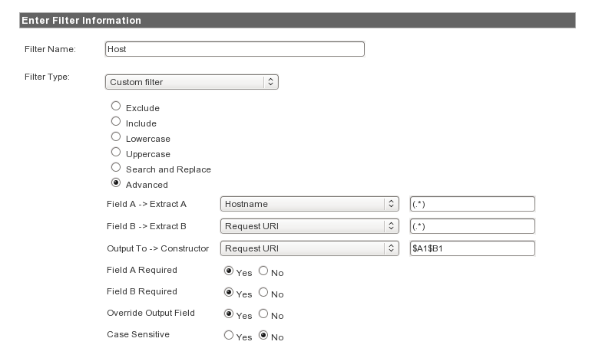

In the above screenshot we have two fields called field A and field B where we provide the ( .*) in that text box. Hostname and Request URI are the two fields that provides all the domain name an URI results separately in the analytics report. After this condition we will get the below screenshot as a result with the separated pages. If you are not filter the result you will get the full content performance as home.aspx only.
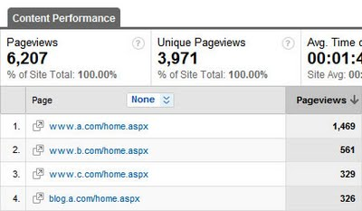
For more information to know about the multiple domain tracking in a single account from the below link
http://analytics.blogspot.com/2009/09/advanced-structure-your-account-with.html

